Manuscripts Container Types

Standard containers

MS Box
Description: Standard brown box
Dimensions (AS Container Profile): 0.15 (w) x 0.28 (h) x 0.40 (d)
Standard Extent (for recording in AS): 0.15 metres (Extent measured by width)
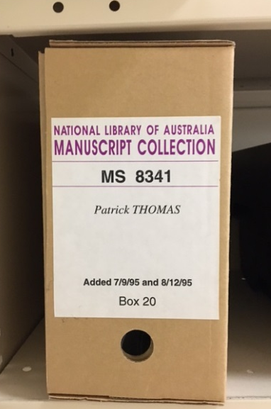
MS Box

Archives Box
Description: Grey-blue or brown standard box, slightly shorter and wider than an MS Box
Dimensions (AS Container Profile): 0.18 (w) x 0.26 (h) x 0.40 (d)
Standard Extent (for recording in AS): 0.18 metres (Extent measured by width)
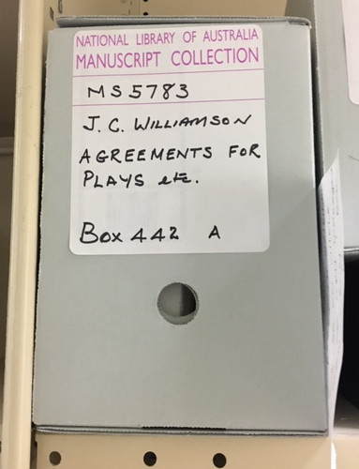
Archives Box
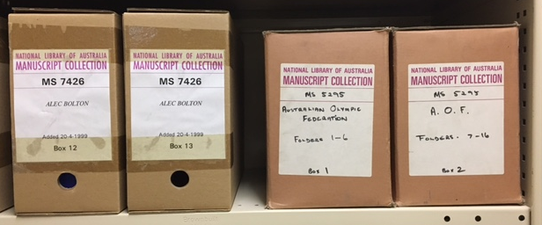
2 MS Boxes shelved next to 2 Archives Boxes

MS Carton
Description: Standard large brown box, sometimes with a lid
Dimensions (AS Container Profile): 0.30 (w) x 0.26 (h) x 0.40 (d)
Standard Extent (for recording in AS): 0.30 metres (Extent measured by width)

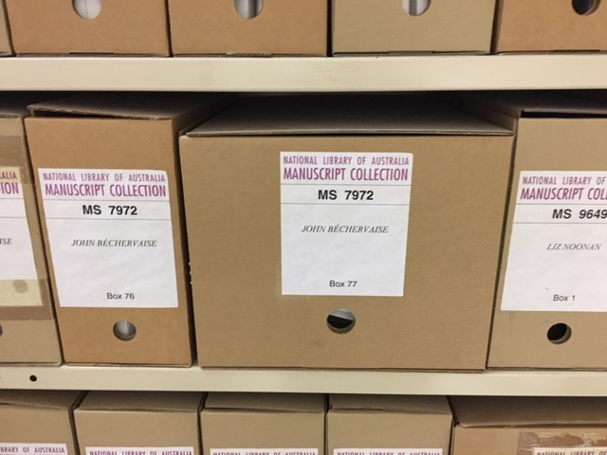
MS carton
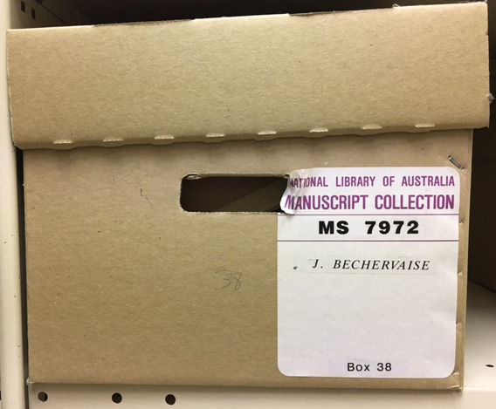
MS carton with lid
Small Folio Box
Description: Standard black plastic box
Dimensions (AS Container Profile): 300 (w) x 390 (d) x 110 (h)
Standard Extent (for recording in AS): 0.3 metres

Medium Folio Box
Description: Standard black plastic box
Dimensions (AS Container Profile): 450 (w) x 390 (d) x 110 (h)
Standard Extent (for recording in AS): 0.45 metres

Large Folio Box
Description: Standard black plastic box
Dimensions (AS Container Profile): 600 (w) x 390 (d) x 110 (h)
Standard Extent (for recording in AS): 0.6 metres

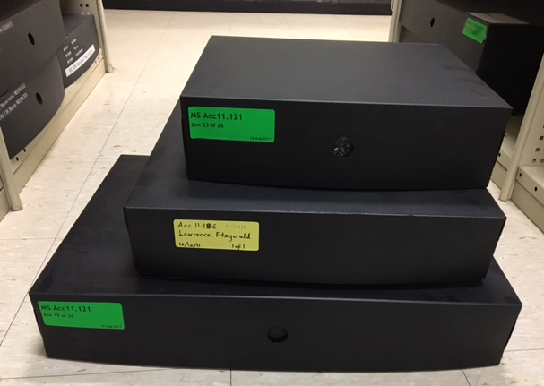
Large, Medium and Small Folio Boxes stacked

Folio Box (Grey – Music – Small)
Description: Standard grey plastic folio box
Dimensions (AS Container Profile): 0.41 (w) x 0.31 (d) x 0.08 (h)
Standard Extent (for recording in AS): 0.41 metres (Extent measured by width)
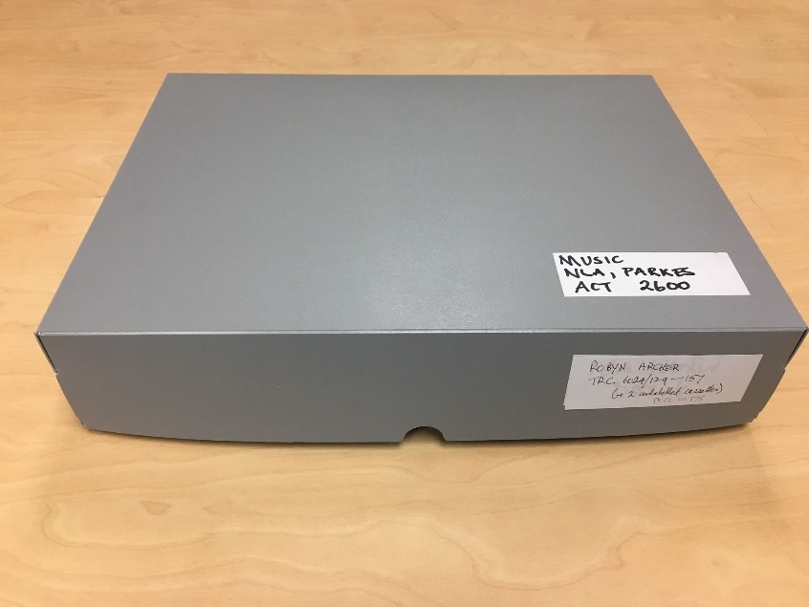
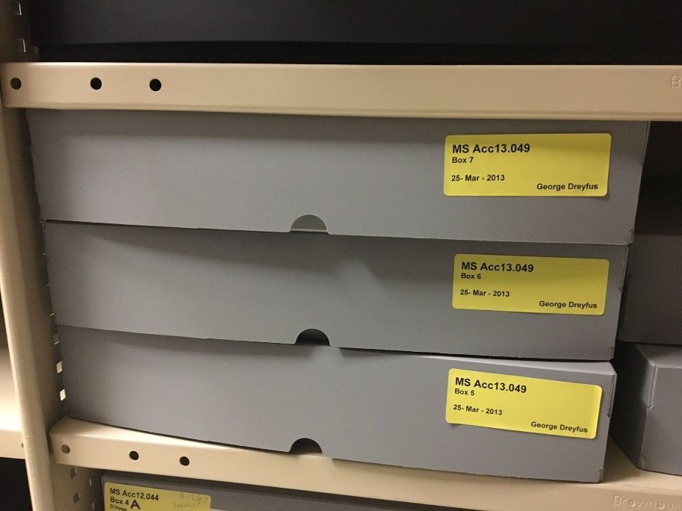

Folio Box (Grey – Music – Large)
Description: Standard grey plastic folio box
Dimensions (AS Container Profile): 0.48 (w) x 0.39 (d) x 0.08 (h)
Standard Extent (for recording in AS): 0.48 metres (Extent measured by width)

Audio Cassette Box
Description: Standard small box for storing audiocassette tapes
Dimensions (AS Container Profile): 0.12 (w) x 0.22 (d) x 0.07 (h)
Standard Extent (for recording in AS): 0.12 metres (Extent measured by width)

Letter Box
Description: Standard small box for storing envelope-sized items
Dimensions (AS Container Profile): 0.07 (w) x 0.24 (d) x 0.37 (h)
Standard Extent (for recording in AS): 0.07 metres (Extent measured by width)

Security binder:
Description: Standard canvas binder
Dimensions (AS Container Profile): 0.07 (w) x 0.35 (h) x 0.3 (d)
Standard Extent (for recording in AS): 0.07 metres (Extent measured by width)

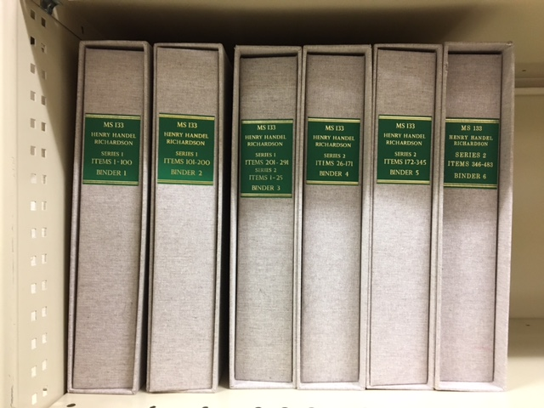
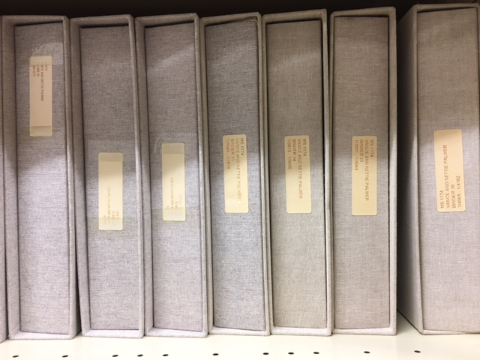

Non-standard containers

**NB: Use the “Measurement Range” to determine the appropriate category of non-standard container, e.g. if a non-standard phase box measures 0.5 m in width then it would fall into the category of “Phase box (medium)” and its extent would be recorded as “0.6 metres”.

Phase box (small)
Description: Grey box custom-made by Preservation
Measurement Range: 0 – 0.30 metres
Dimensions (AS Container Profile): 0.30 (w) 0.40 (d) 0.06 (h)
Standard Extent (for recording in AS): 0.30 metres (Extent measured by width)

Phase box (medium)
Description: Grey box custom-made by Preservation
Measurement Range: 0.31 – 0.60 metres
Dimensions (AS Container Profile): 0.60 (w) 0.40 (d) 0.14 (h)
Standard Extent (for recording in AS): 0.60 metres (Extent measured by width)

Phase box (outsized)
Description: Grey box custom-made by Preservation
Measurement Range: 0.61 – 0.90 metres
Dimensions (AS Container Profile): 0.90 (w) 1.0 (d) 0.29 (h)
Standard Extent (for recording in AS): 0.90 metres (Extent measured by width)
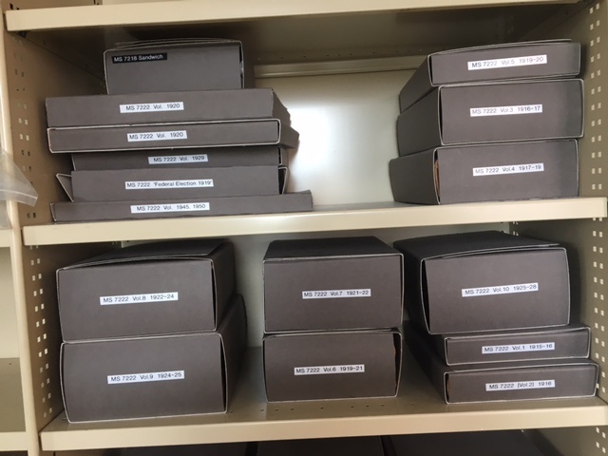
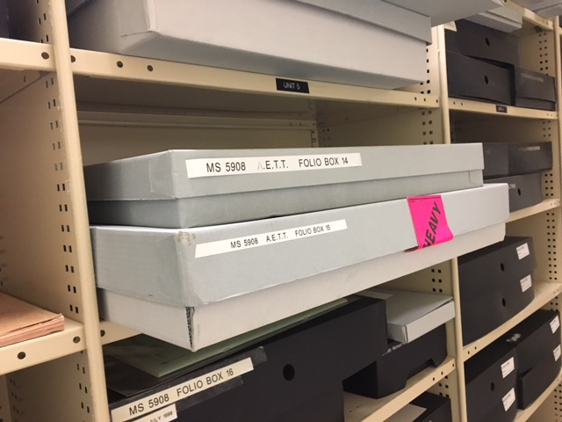
Examples of phase boxes

Archives Carton
Description: Non-standard carton
Measurement Range: 0 – 0.45 metres
Dimensions (AS Container Profile): 0.45 (w) 0.40 (d) 0.29 (h)
Standard Extent (for recording in AS): 0.45 metres (Extent measured by width)

Roll
Description: Poster tube or other rolled item
Measurement Range: 0 – 1.5 metres
Dimensions (AS Container Profile): 1.5 (w) 0.20 (d) 0.1 (h)
Standard Extent (for recording in AS): 1.5 metres (Extent measured by width)

Object (Small)
Description: Non-standard object
Measurement Range: 0 – 0.30 metres
Standard Extent (for recording in AS): 0.30 metres

Object (Medium)
Description: Non-standard object
Measurement Range: 0.31 – 0.60 metres
Standard Extent (for recording in AS): 0.60 metres

Object (Large)
Description: Non-standard object
Measurement Range: 0.61 – 0.90 metres
Standard Extent (for recording in AS): 0.90 metres

Map Folio/Drawer
Description: Flat folio item the size of a map drawer or smaller
Measurement Range: 0 – 1.1 metres
Standard Extent (for recording in AS): 1.1 metres

Elephant Folio
Description: Oversize flat folio item (larger than a map drawer)
Measurement Range: 0 – 1.5 metres
Standard Extent (for recording in AS): 1.5 metres

Volume (standard)
Description: Bound volume that fits inside a box
Measurement Range: 0 – 0.03 metres
Dimensions (AS Container Profile): 0.27 (h) 0.40 (d) 0.03 (w)
Standard Extent (for recording in AS) : 0.03 metres (Extent measured by width)

Volume (large)
Description: Bound volume stacked upright on shelf
Measurement Range: 0 – 0.15 metres
Dimensions (AS Container Profile): 0.27 (h) 0.40 (d) 0.15 (w)
Standard Extent (for recording in AS): 0.15 metres (Extent measured by width)
