- Right click the start menu and select system:
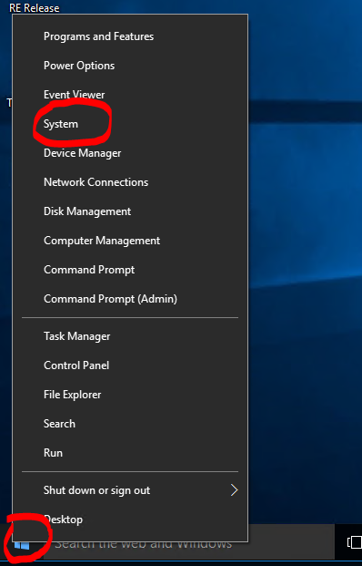
- In the Window that pops up, click Advanced System Settings
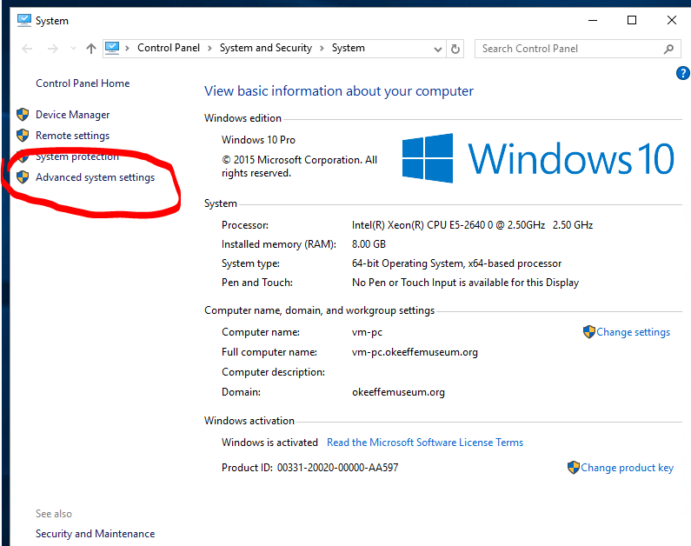

- In the window that pops up click Environment Variables
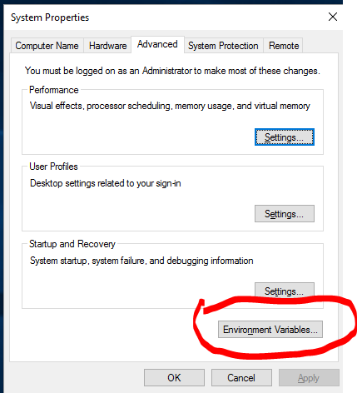
- In the window that pops up, in the lower pane, find the Path variable and click Edit
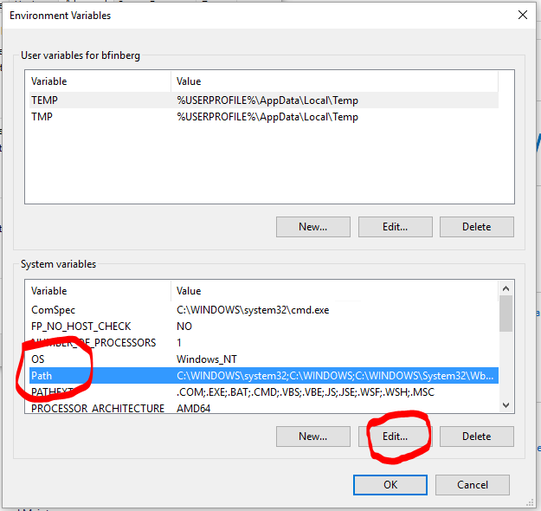

- In the window that pops up, click New and add the line the bin directory of your for your Java location. (For you it would be c:\Program Files (x86)\Java\jre1.8.0_77\bin) And hit OK.
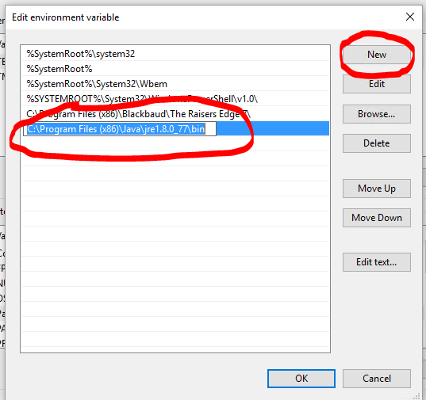
- Back on the Environment Variables window, click New on the bottom:
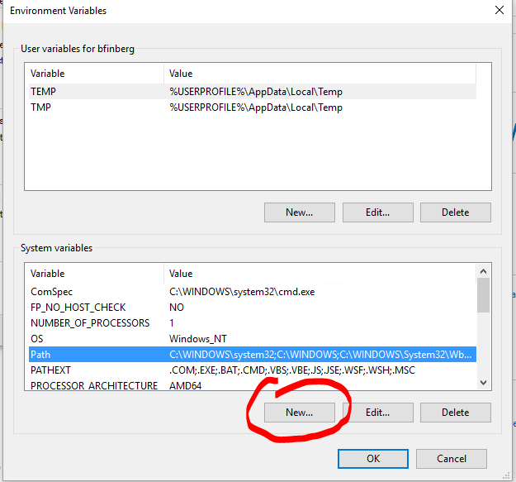
- In the window that pops up, for variable name type JAVA_HOME and for path set it to the Java directory (the same one as above, minus the bin at the end) and hit OK.
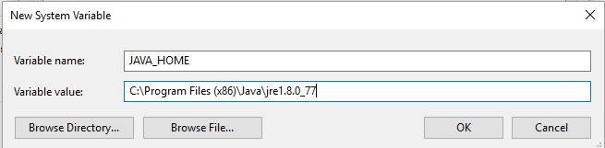
- OK your way out and reboot. You may need to do some of the subsequent steps again from there, or it may start working after the reboot.

