**Harvard Library ArchivesSpace Implementation Working Group report:**

**System issues submitted to the Lyrasis ArchivesSpace development team, 4/9/2015**

**Functionality**

* The “Edit” view of an accession record should include events. Right now, it does not. This means that you can inadvertently create a duplicate event record without realizing it.

**Data display issue**

* There appears to be a relationship between the processing status and processing priority fields that results in a “translation missing” error when one of the fields is populated but the other field is empty. This occurs with both migrated records and records created in ArchivesSpace. Here are screenshots of the problem:

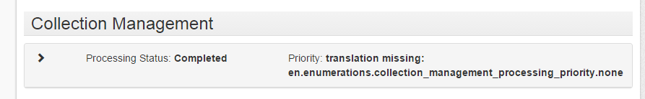

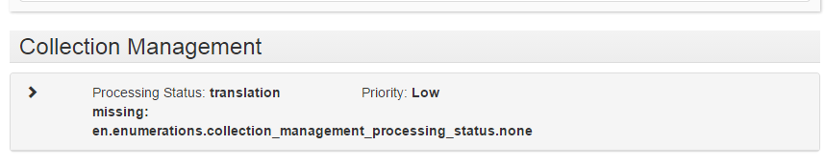

**User Interface issues**

1. The ability to adjust the left-hand navigation panel would be highly desirable to allow flexible use of the screen real estate.
2. For the “Advanced Search” option, can the “down” arrow be replaced with something more clearly indicating that this is the way to activate advanced search options? The purpose of the “down” arrow by itself is not intuitive.
3. Would it be possible to redesign the presentation of basic information in Accession records so that key information – Creator, Title, Dates, Extent –displays “above the fold”? Right now, this information displays “below the fold” so that it is difficult to know at a glance what the accession record represents and finding this key information requires a good deal of scrolling.
4. Navigation in the User Interface could be improved. Examples:
   1. Having to scroll to bottom of an Event record and click on link to accession to return to the accession record you started on.
   2. Inconsistent location of the Edit button: on the left in some cases, on the right in others.

Are there plans on the books to work on the staff user interface?