**Harvard Library AT-to-ASpace data migration issues and ASpace functionality:**

**Harvard follow-up to Lyrasis response from Chris Fitzpatrick on 9/29/2014**

**10/22/2014**

This follow-up to Chris Fitzpatrick’s response (9/29/2014) to Harvard’s report re migration and other issues (9/26/2014) focuses on three specific issues:

1. Migration of subject subdivisions from AT to Aspace
   1. Topical subject heading subdivisions
   2. Name subject heading subdivisions
2. Rapid Data Entry
3. ASpace user interface
4. **Migration of subject subdivisions from AT to ASpace**

**Original report text:**

* Since there are no assigned types for subdivisions in the AT, subdivisions migrated from the AT should have types defined as ingested or unknown rather than automatically assigned types (currently “genre/form” for names and “topical” for subjects). Migration-specific assignments would prompt the user to assign the correct type to a term whereas automatic assignments are likely to lead to the assumption that the assigned types are correct.

This is a high priority because we don’t want to reclassify all of the topical subdivisions

As our initial statement was confusing, we are providing more information about the problem.

**1a. Topical subject heading subdivisions**

**Further explanation with examples:**

There is no way to apply a “Type” to a subject subdivision in the AT. Subdivisions on subject headings in AT are designated only by a double hyphen "--". When the main heading and subdivision are migrated to ASpace, the double hyphen is interpreted as a subdivision separator, and the same “Type” is applied to the main heading and to the subdivision. See screenshots below where “France” is defined as a topical heading and not a geographic heading.

Corrections of these subdivision "Types" is highly desirable in a future of linked data. It is possible for a user to edit individual records in ArchivesSpace. However, to facilitate manual or programmatic corrections, it would be necessary to differentiate between a subdivision "Type" assigned during migration and a subdivision "Type" that has been vetted for accuracy.

**AT screenshot:**

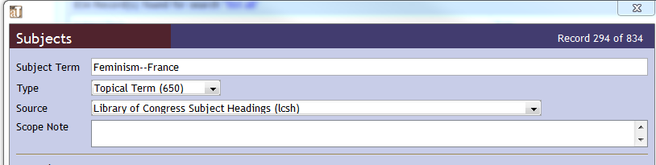

**ASpace screenshot:**

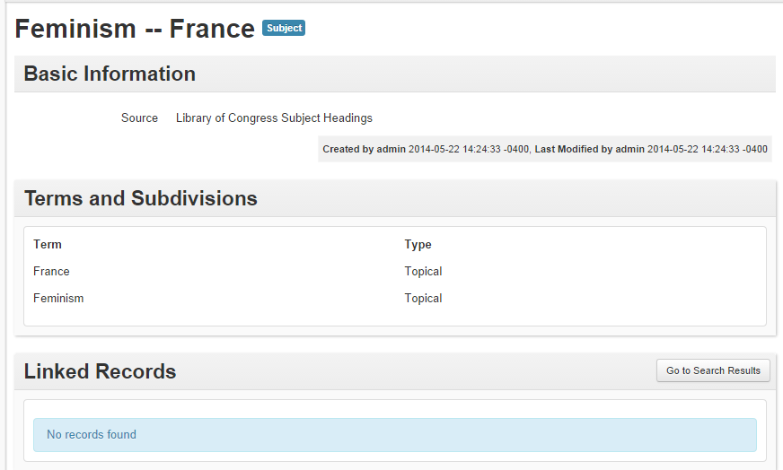

**Clarifying background:**

Subjects in AT can be designated as:

* Function
* Genre / Form
* Geographic Name
* Occupation
* Topical Term
* Uniform Title

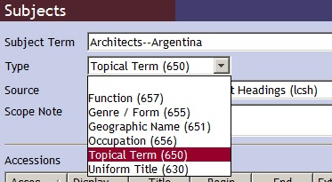

Subject subdivisions are demarcated with two hyphens in AT. Subdivisions are often not the same Type as their main term. For example, "Architects" is topical, but "Argentina" is geographic. AT does not assign Types to subdivisions. In fact, the entire subject is just a text string.

When subject terms are migrated from AT to ASpace, ASpace parses the subdivisions based on the presence of a double hyphen; this is good. Unfortunately, by default ArchivesSpace assigns the same Type to the subdivision as to the parent term. For example, Architects--Argentina (in AT) translates to Architects (Topical) and Argentina (Topical).

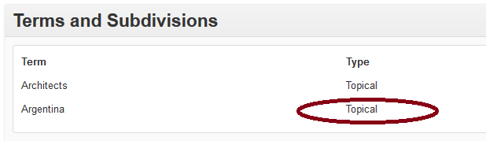

This is a problem that will require hundreds of corrections. However, it will also require ***recognition*** of problem subdivision types. Given that the types assigned during migration are all perfectly legal, it will be impossible to identify which ones require correction, eitherprogrammatically or by searching, among the thousands of subject subdivisions that have been migrated.

**Proposed solutions:**

We have a few ideas that might help us to cull the subject subdivisions requiring vetting for accuracy and correction from the large number of migrated headings:

* Assign type "migrated" to subdivisions (i.e. to any subdivision parsed on the basis of double hyphen from AT)
* Assign type "undefined" or "unknown" to subdivisions (i.e. to any subdivision parsed on the basis of double hyphen from AT)
* Of course, this means that we would need some means of finding subject subdivisions based on their Type.

**1b. Name subject heading subdivisions**

**Further explanation and example:**

Following instructions in the ArchivistsToolkit user manual relating to the creation of name subdivisions,[1] subdivision values are created through the Name Link Form lookup list:

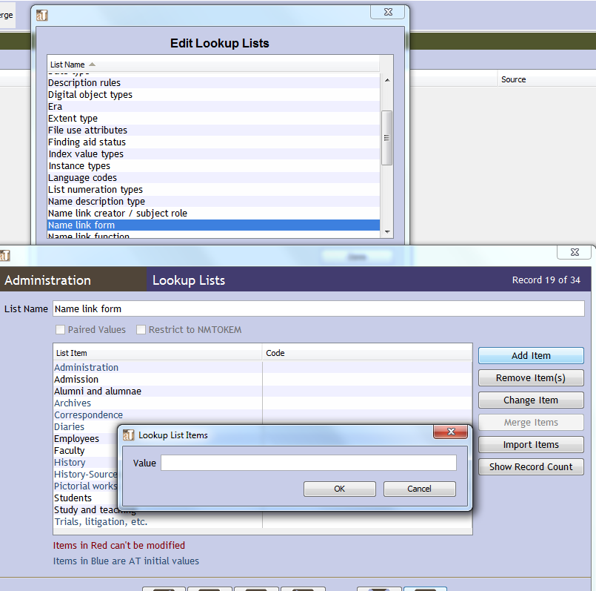

Once a value has been created, it can then be assigned to a name using the Form Subdivision function:

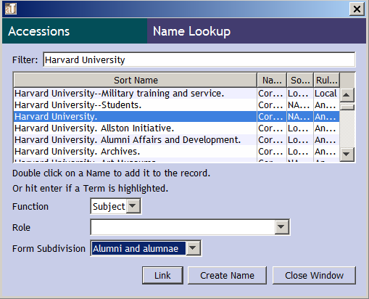

A Type cannot be assigned to the subdivision in the lookup list or via the Form Subdivision. When subdivided names are migrated from the AT to ArchivesSpace, they import correctly as subdivided names, but the subdivisions are assigned a seemingly random Type.

For instance, in the below example, both subdivisions are *topical* Types, but while "Trials, litigation, etc." migrates as a *topical* Type, "Employees" migrates as a *form/genre* Type.

1. **Rapid Data Entry issue**

**Original report text:**

In Rapid Data Entry, sticky field and "fill column" functions don't seem to work for "publish.”

**Lyrasis response, Harvard follow-up in red:**

*Wow, that is a bug. Surprised nobody has noticed that yet...made a ticket here*

[*https://www.pivotaltracker.com/story/show/79681132*](https://www.pivotaltracker.com/story/show/79681132) *and will try and get a fix in time for the next release... Actually, I just checked the RDE issue and it does seem to be working for Publish?. I think I didn't have it set as a sticky when I first checked the issue. Can others verify this as well? b,chris.*

* I retested and still find that if I manually check Publish in the RDE, everything works fine, but the Sticky Column and Fill Column functions don’t seem to be working with Publish.

This is what the RDE page says about sticky columns:

Sticky Columns

Highlighted columns are sticky and will be replicated when new rows are added. Toggle 'sticky' by clicking the corresponding table heading.

Clicking Add Row will copy values from the last row; The row's + button will copy values from the currently focused row.

In the below example, Publish is a highlighted column, but when I select Add Row, the new row doesn’t have Publish selected.

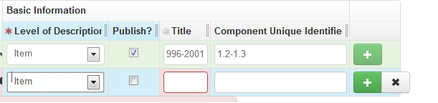

If I select the Publish column using the Fill Column function, nothing happens when I click the Apply Fill button.

1. **User interface issues:**

**Original report text:**

We have significant concerns about the user interface. Users should be able to recognize and interpret a record at a glance. The verticality of the design and excessive white space result in huge amount of scrolling and clicking to expand the display. For example, many fields contain information that is far longer than the display, resulting in truncated text. Why should this happen when there appears to be plenty of screen space to expand the boxes to fit the content.

**Lyrasis response, Harvard follow-up in red:**

*In regards to the UI changes, I think those will have to be taken up with the relevant subgroups. However, I will mention again it's pretty easy to tweak the UI to display the information that you're wanting. I think most could be done with some minor edits to the template.*

*In regards to the documentation, we have a subgroups on both the user and technical advisory committees working on improving what's there. Also, please feel free to send questions to the list.*

* **What is the best way to convey issues/ concerns to these subgroups? Are there representatives we can contact?**

*In regards to the UI issues, I have to note that ArchivesSpace UI is completely customizable, so you can modify it in a way that suits you best. Things like reordering the fields, or adding some text at the top of the record are pretty easy to do and can be added as a plugin to your installation.*

* **Will there be instructions/ guidance on how to do customizations to the interface?  Are you planning on holding workshops/ trainings on how to do customizations?**

*In regards to the UI changes, I think those will have to be taken up with the relevant subgroups. However, I will mention again it's pretty easy to tweak the UI to display the information that you're wanting. I think most could be done with some minor edits to the template.*

* **Can you provide some examples of how we might do this? Or- possibly talk with us on the phone and we can do screen shares?**

1. "**Form Subdivision**. This field is for topical, geographical, chronological, or form descriptors, singly or in some combination, that modify a name assigned as a subject." (<http://archiviststoolkit.org/sites/default/files/AT1_5_UserManual.pdf>, p. 194. Accessed 2014-11-14)