Harvard Libraries AT to ArchivesSpace Issues to Report
2014-09-26

Data Migration issues:

- On export from AT to ArchivesSpace, external links in accession and resource records to files on a network server no longer work due to the insertion of “file://”. Can this be fixed?

This is a high priority because we use external links extensively in accession and resource records.

- Since there are no assigned types for subdivisions in the AT, subdivisions migrated from the AT should have types defined as ingested or unknown rather than automatically assigned types (currently “genre/form” for names and “topical” for subjects). Migration-specific assignments would prompt the user to assign the correct type to a term whereas automatic assignments are likely to lead to the assumption that the assigned types are correct.

This is a high priority because we don’t want to reclassify all of the topical subdivisions

- Correcting subdivision types in the subjects module currently reorders the terms and subdivisions resulting in subdivisions being promoted to main entry headings. For instance, the entry “African American women—United States” migrates with the United States subdivision as topical. When the United States type is changed to geographic, the saved result becomes “United States—African American women.”

It sounds like this is being fixed in the next release, but wanted to point this is an issue for us as well.

- We noticed a translation missing error for the rights transferred note. The label appears as "translation missing: en.enumerations.event_event_type.rights_transferred (8770)".

User support issues:

- We encountered a number of problems with finding documentation/help for using ASpace. What are plans for writing documentation and providing easy access to help? One example:
  - How do individuals and repositories configure settings?

User interface issues:

We have significant concerns about the user interface. Users should be able to recognize and interpret a record at a glance. The verticality of the design and excessive white space result in huge amount of scrolling and clicking to expand the display. For example, many fields contain information that is far longer than the display, resulting in truncated text. Why should this happen when there appears to be plenty of screen space to expand the boxes to fit the content.

Individual records

- Individual accession record displays should display more data at the top of the record specifically. This does not have to be the editable data, but should at least display so the user knows they are looking at the correct record.
1. Accession number
2. Accession creator
3. Accession source
4. Accession title
5. Begin date
6. End date
7. Whole extent number
8. Whole extent unit of measurement

- Editing resource records would benefit from:
  - alternate row shading
  - ability to double click on file level to open new edit window (rather than having to scroll down) **or** edit fields open at right as in AT.
  - arrow-key navigation of file tree
  - In Rapid Data Entry, sticky field and "fill column" functions don't seem to work for "publish.”

- Viewing and editing Agent records:
  - The order of information should be logical, with the most important information appearing first: name parts, dates, rules, source

- Viewing and editing Event records:
Event records don’t seem to be well-integrated with the interface.
  - Once an event is created, it appears in the view version of the accession record, but there is no indication of it in the edit version. If you are working in the edit mode, you could easily overlook the existence of an event record and create multiple event records for the same event. The only way to edit or delete an event is to go to the view mode of the record and select edit in the event record. This is very inefficient. We need to be able to do this from the record edit view.
  - Users were also confused by labels and Agent roles.

Reporting and printing needs
Assuming that reporting needs will be addressed in depth by the user’s group, here are a selection of key considerations that we need to see addressed.

- We need to be able to limit an accession report between dates of accession, not the date the accession record was created.

- Default reports should contain more information from each record than we currently see. A good starting point would be the data fields indicated in “Requested changes #1”, below.

- We would like to be able to save and print an accession receipt, similar to Archivists’ Toolkit.

- We need to be able to print out a single/full accession record.

- Will there be other accession and resource record export options available? A PDF export would be very useful for editing/printing purposes.

Critical Bug

- You can delete an accession record through the Collection Management record.

Searching, Facets, and Record Lists

Overview
The current search interface that archival staff encounters in ArchivesSpace provides a combination of text searching, text "filtering," and faceting. These are features consistent with many current discovery products; however, archivists in their daily work seek information in ways that researchers do not. Archivists often hunt for "known unknowns" or seek comprehensive lists of holdings that meet a set of criteria.

User stories
Unlike researchers using a discovery system, Archival staff are often using collection management systems to recognize known items from ill-remembered details or to understand a range of information about repository holdings based on any number of possible (and impossible to forecast) criteria. Archivists ask questions such as:
- "I can't remember if those were audio or video tapes. They're in that accession that has the photo of the guy with the mustache and was packed in a tan suitcase. Which one was that?"
- "So, which departments send us student records but haven't sent us administrative records recently?"
- "Which personal archives have artwork in them?"

Other features are often of great use in recognizing a "known unknown."
- Size is often the recognizable feature that triggers a staffer's memory as to which of many similar accessions of institutional records they are seeking.
- For personal archives, the source is often the distinguishing feature of an accession. We have one faculty member whose (as yet unprocessed) personal archive was acquired in 31 separate accessions.
- When searching by format or medium, recognizing creator is often an important additional piece of information. Searching by creator is not a useful mechanism for doing this if the user does not remember a creator name, but instead is relying on the possibility of recognizing it.
- When dealing with agents, name alone is not sufficient. Example: there are five people named Oakes Ames represented in our collections.

Desired characteristics of the interface
Features that provide the best comprehensive view of resources and accessions and assist with recognition are:
- Lots of information on screen
- Sorting

Current interface
As of September 2014, ArchivesSpace shows only a limited amount of information on screen in search results/lists of records and provides limited options for sorting.

Information in search results/lists of records is limited in three ways:
1) ArchivesSpace displays only 10 records at a time.
This leaves archivists unable to quickly scan lists.
2) ArchivesSpace display limited information about each accession or resource.
Users must open record after record to see vital information.
3) ArchivesSpace facets are limited to "popular" values only.
Archivists are unable to see the full range of relevant data.

Holistic design note
The interplay between faceting and list content means that some of our recommendations may be conditional. For example, if "creator" and "source" were included in the list of accessions, and if these were sortable, the request that a user be able to sort facets would be of less importance.

Requested changes

- More information from each record should appear in the record lists. (Figure I.) Audit trail information (date of record creation and agent) is unnecessary in list of records.

Data for a list of accession records:
a. Accession number (shown if configured)
b. Accession creator (not availble in ArchivesSpace search interface)
c. Accession source (not available in ArchivesSpace search interface)
d. Accession title (shown by default)
e. Begin date (not availble in ArchivesSpace search interface)
f. End date (not available in ArchivesSpace search interface)
g. Extent (not available in ArchivesSpace search interface)
h. Extent unit of measurement (not available in ArchivesSpace search interface)
i. Date accessioned (shown if configured)
j. Date of receipt (locally defined field, not available in ArchivesSpace search interface)
k. Processing status (not available in ArchivesSpace search interface)

Data for a list of resource records:
a. Resource identifier/call number (shown if configured)
b. Creator (not available in ArchivesSpace search interface)
- For individuals, "name" includes fuller forms of name and dates
c. Title (shown by default)
d. Begin date (not availble in ArchivesSpace search interface)
e. End date (not available in ArchivesSpace search interface)
f. Extent (not available in ArchivesSpace search interface)
g. Extent unit of measurement (not available in ArchivesSpace search interface)

2. Facets
a. Should appear in alphabetical order rather than by popularity (i.e. number of records). Alternatively, users should be able to toggle between displaying facets alphabetically or by popularity. (Figure II.)
b. Date facets, these should be sortable by date descending and date ascending.
c Personal names in facets should include dates and fuller forms of name in order to differentiate between identically-named individuals.
d. Subjects and form/genre terms are combined in one facet grouping. The following groups of facets are desirable:
- Persons
- Corporations
- Subjects
- Form/genre
e. In order to provide added screen real estate, it would be useful if facets could toggle between visible and hidden at a user's request.

Figure I | 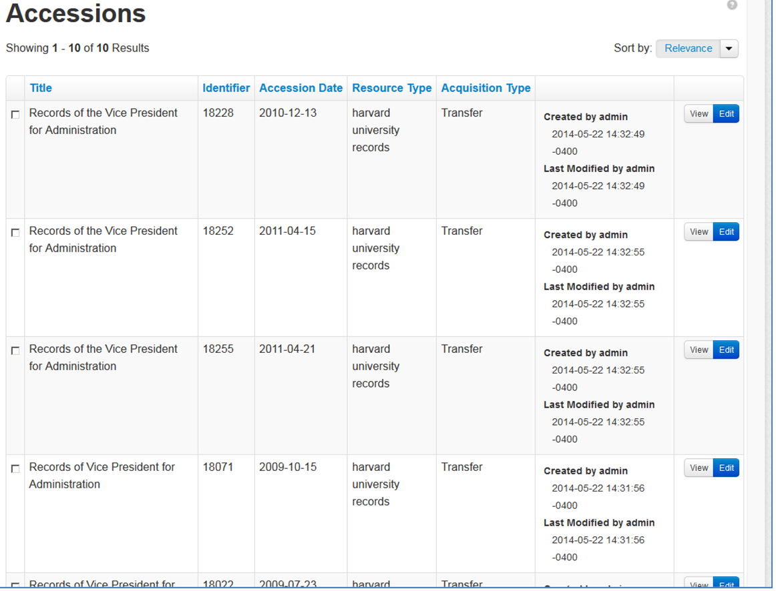  Figure I: Legacy accession titles do not convey sufficient information to recognize an accession. Creator, source and other information is necessary.
Figure II | 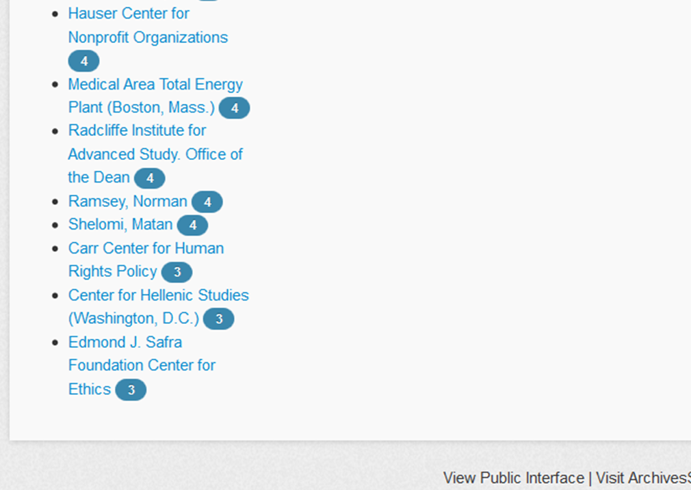  "Unpopular" values do not display among facets. In this view, the last complete list is values with 4 records. Those with "3," are cut off mid-alphabet. Those with 2 or fewer are not listed. With nearly 7000 accessions migrated to ArchivesSpace migration, and at least 6000 more legacy accessions that could be added, the impact of showing only popular facets will increase.

